Completing the Survey
The vaccine survey is available on the HR Solutions Hub. All employees have access to complete the survey directly on the HR Solutions Hub. Employees who would prefer to provide their responses via phone should contact HR Solutions at 1-877-7EXELON (1-877-739-3566).
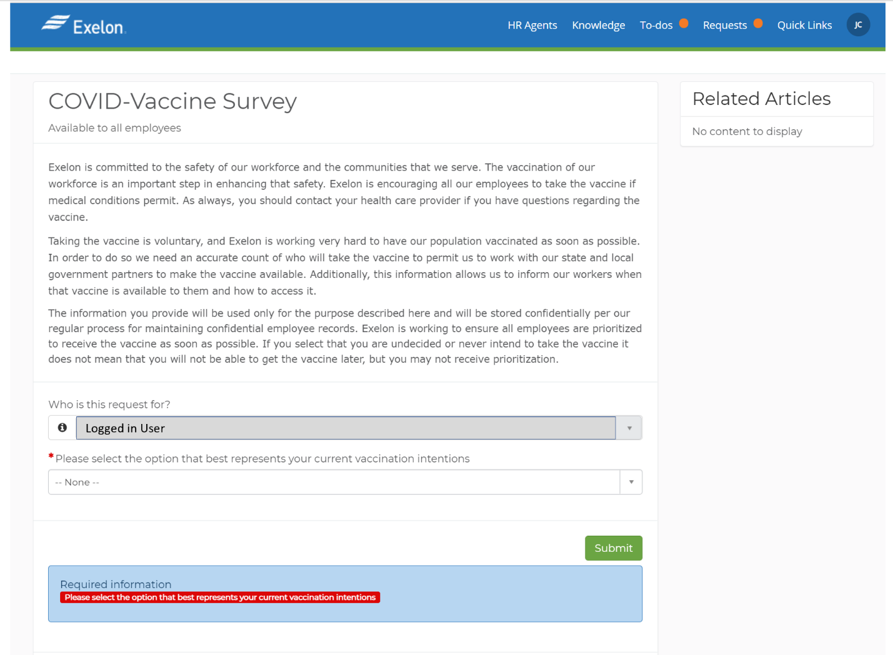

Vaccine Intention Options
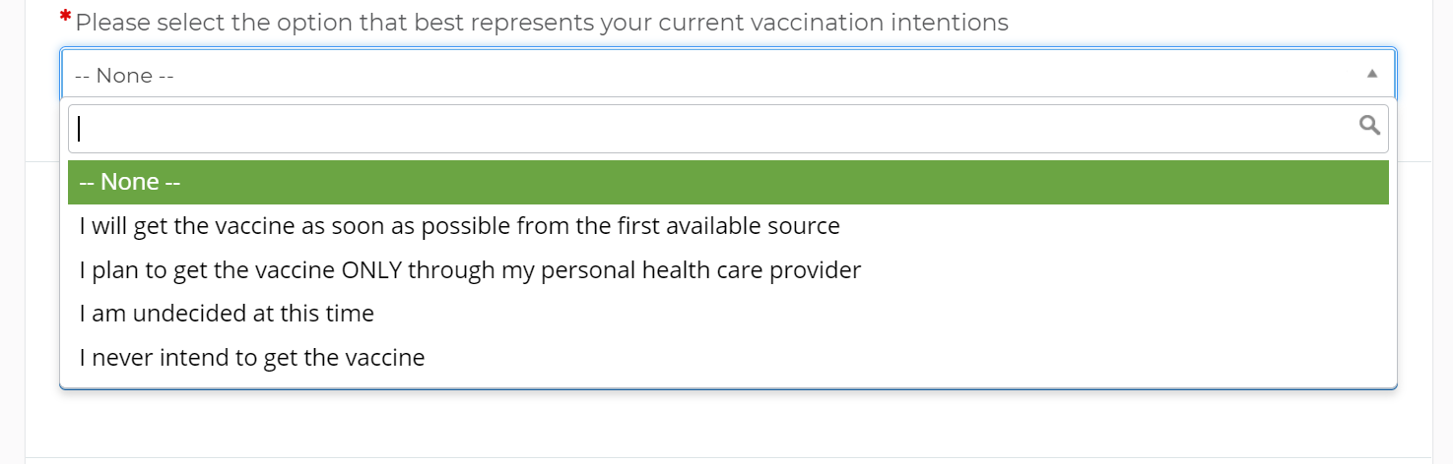

HR Solutions Hub Access
If prompted for log-in credentials, you will use LANID@exelonds.com (e.g., E070045@exelondscom or BRICAD@exelonds.com) to gain access. Your password is your Exelon network password. If you encounter difficulties logging in or would prefer to provide your response via phone, please call HR Solutions at 1-877-7EXELON (1-877-739-3566). Additional details on logging in are provided below.

Logging in from the Exelon network
If not yet logged into an application that uses the same SSO set-up as ServiceNow, you may be asked for your credentials as shown below:
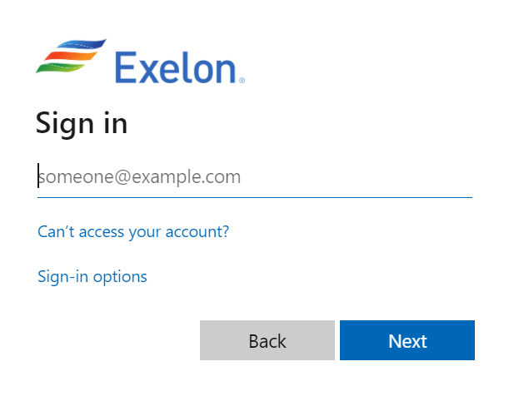

When presented with this screen, please enter your Username@exelonds.com and password.
- Note: Username is synonymous with LAN ID
- Examples: BRICAD@exelonds.com or E070045@exelonds.com
- Be sure to use exelonds.com and NOT exeloncorp.com
After entering your credentials, you will be prompted to complete a multi-factor authentication that requires the Microsoft Authenticator app. If you have not previously used the authenticator app, below are directions on how to install the app for first time use.

Microsoft Authenticator Application Job Aid
Review the job aid by clicking the icon below.

Logging in Off the Exelon Network
If you are off the Exelon network, you will be taken to the page pictured below:
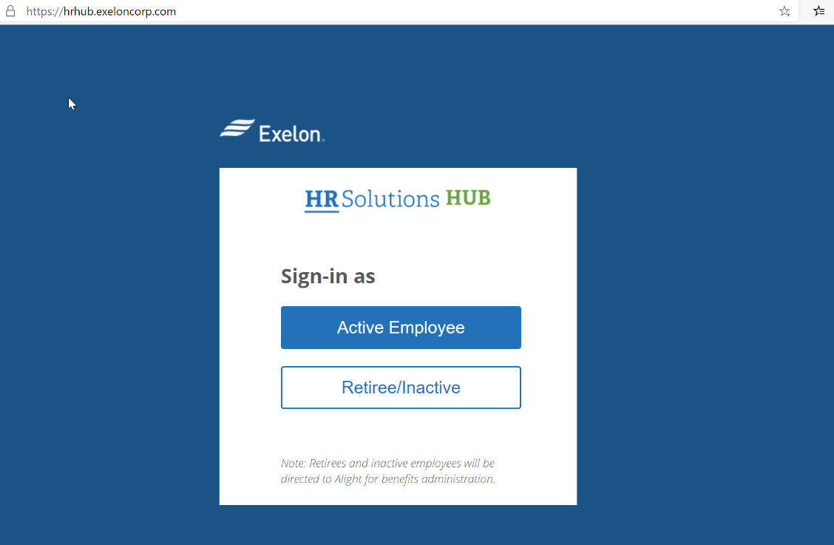

Please select “Active Employee”, and you will be taken to ServiceNow. Follow the same exact steps as described in “Logging in on the Exelon Network” section above to access the survey.
PLEASE NOTE: Microsoft Edge browser is the preferred for the HR Solutions Hub. For assistance downloading Microsoft Edge, please select the appropriate link below.
Self Service - Microsoft Edge on Android Devices (service-now.com)
Self Service - Microsoft Edge on iPhone/iPad Devices (service-now.com)

