My Story: A Vaccination by Chance – Leah Covington, Director HR, BGE
It was a normal “work-from-home during COVID-19” day when I got an unexpected phone call from a friend.
Of course, as soon as the phone rang, my dog, Zoey, started barking—wanting to be part of the conversation. Having dogs and kids in the background during conference calls is just another part of the “new normal,” though, right?
My friend, who works at a Community Health Center in Baltimore, wanted to know if I could come get the coronavirus vaccine. They had several “no shows” and were trying to make the most of their supply. The vaccines have a short shelf life once they’re opened, so they were calling supporters to come get vaccinated instead of it going to waste.
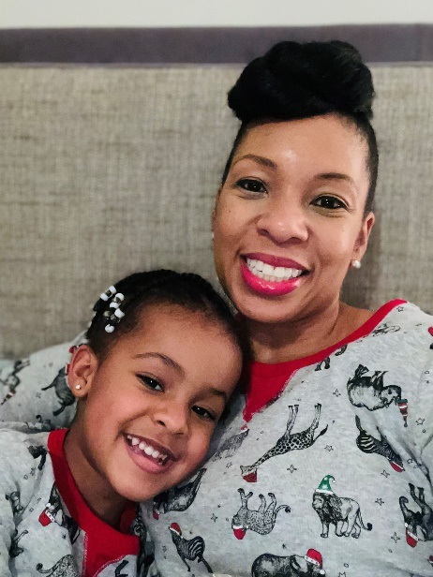
Having had COVID several months ago, I was very happy to get that call. I rearranged my back-to-back meeting schedule to squeeze in an hour and go to the clinic. I had to do it for my daughter, Leana. There’s no vaccine for kids right now, so the best thing I can do to protect her is protect myself.
I still remember the emotional toll of having COVID and the fear of potentially passing it on to her. She’s only three and so it was impossible to quarantine her when I was sick. So, of course, she got it too.
And then, we were scared about her recovery. Thankfully, we’re all okay and we were able to spare our elderly babysitter from catching it. I sent her home as soon as I felt even a little unwell.
That’s the key to stopping the spread. Don’t ignore symptoms— quarantine and get tested.
On Thanksgiving, after cooking all day for my small family, I wasn’t just tired—I was exhausted. I went and got tested on Black Friday and sure enough, I was positive.
That resulted in a total lockdown of our house. No one was coming in or going out. It was several weeks before we even had the babysitter come back. That was months before I got the call from my friend.
After we hung up, she made an appointment for me at 12:42 p.m., which was a very strange time. All I had to do was bring my ID. The medical assistant asked me 10-12 questions similar to what they ask when you get the flu shot. I barely felt the actual shot. Then, they moved me to an observation area for 15 minutes. The whole process took about 45 minutes, and I left with a stamped card and a return appointment.
That night, I felt a little sore, but not enough to even take acetaminophen. That morning though, I woke up with what felt like the flu. I was achy, tired and had a sore arm, but no nausea or fever.
For several days, I received text messages from the Centers for Disease Control and Prevention (CDC) as part of its “V-Safe Website” and vaccination program. They have you check-in to make sure you’re doing okay. It was reassuring.
If I had one thing to share with you, it would be that anyone can get COVID-19. Even little Zoey, our bichon cocker spaniel, got it. That’s why I wanted to share my story—to say anyone can get it and the best thing we can do is get vaccinated. If you’re like me, you don’t ever want to be responsible for passing it along to someone who might not recover.
Please register and get the vaccine as soon as it’s available to you. You’ll be protecting not only yourself, but your loved ones and their loves ones too.
Leah
PS: Zoey’s fine, by the way.

